Name:  Teacher : | ____________________________________  ______________________ |  | Date:_________
 | Year 7  Part 2  Transformations and Symmetry
Total Time: | 45 minutes | Conditions: Calculator, notes from in class preparation allowed
Weighting: | 7%
Equipment: | Calculator, pen, pencils, eraser

Question 1 (1 + 1 + 2 + = 5 marks)
Draw the image resulting from the following transformations:
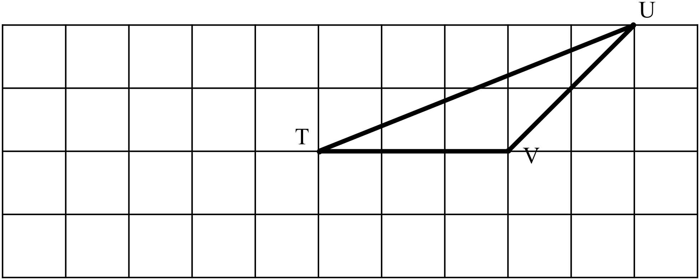Label the vertices of the image appropriately.

- Translate 5 units left

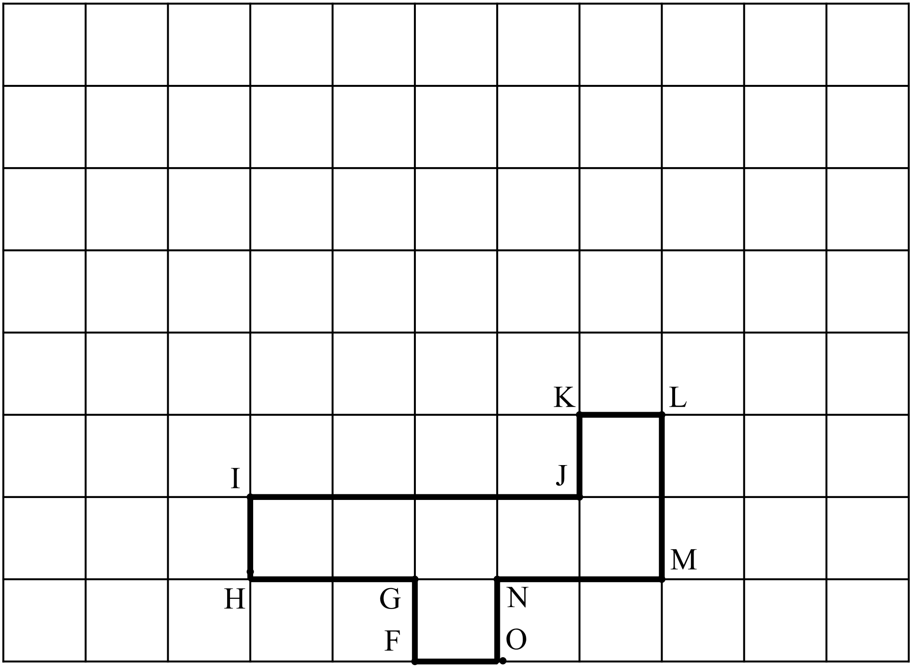
- Translate 5 units up

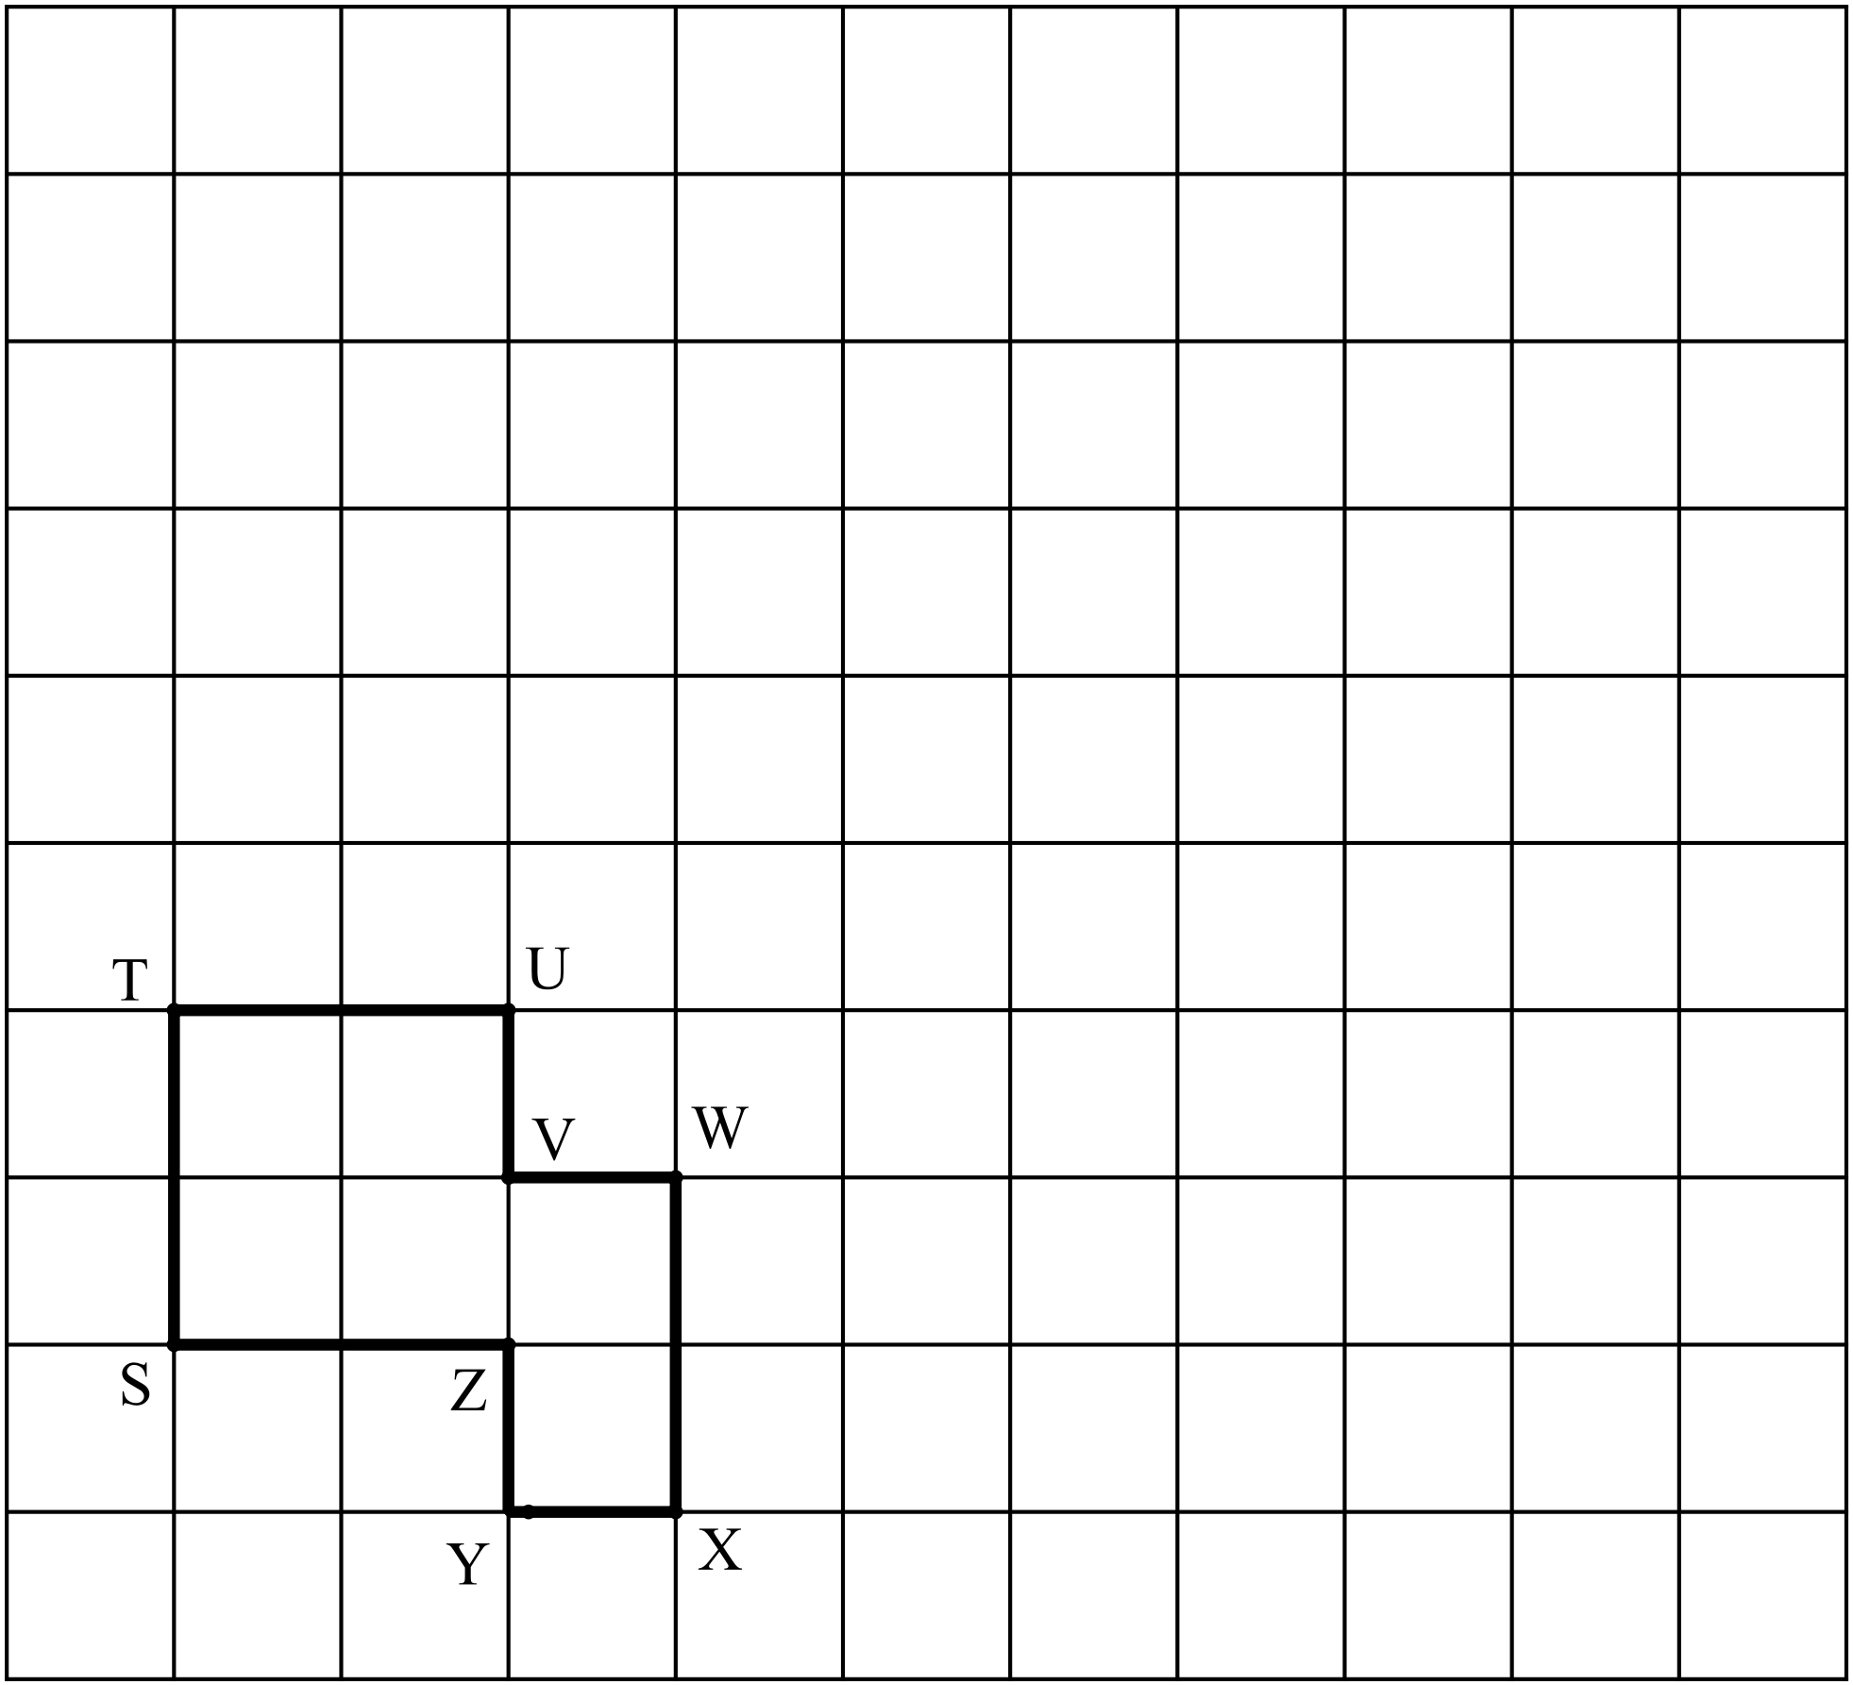

- Translate 2 units right, 6 units up

Question 2 (2 + 2 = 4 marks)
Reflect the following objects over the line XY labelling the vertices of the image appropriately.
- 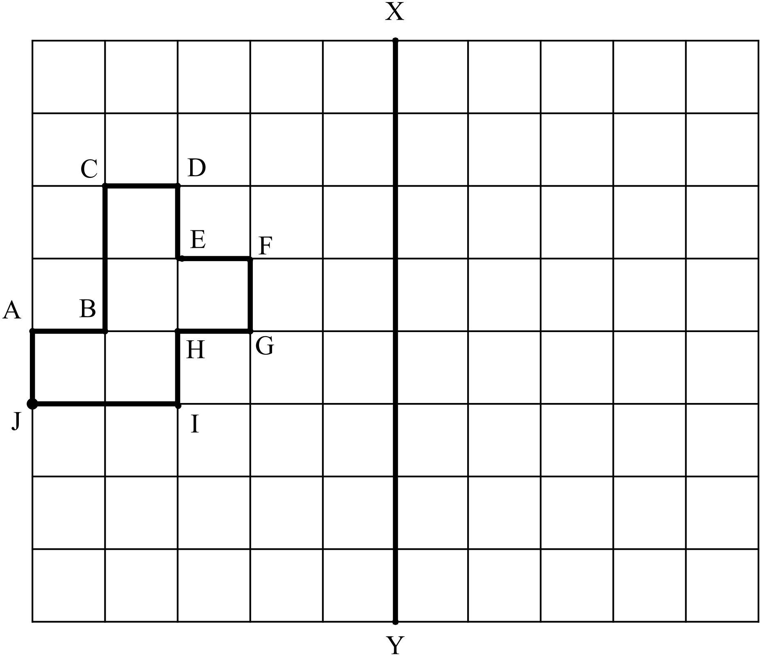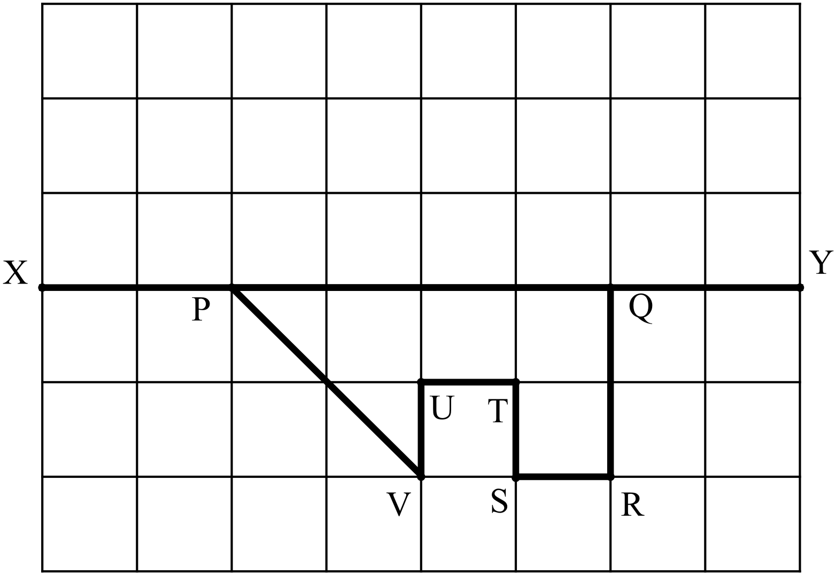 b)

Question 3 (2 + 2 = 4 Marks)
Rotate the following objects, labelling the vertices of the image appropriately:
- 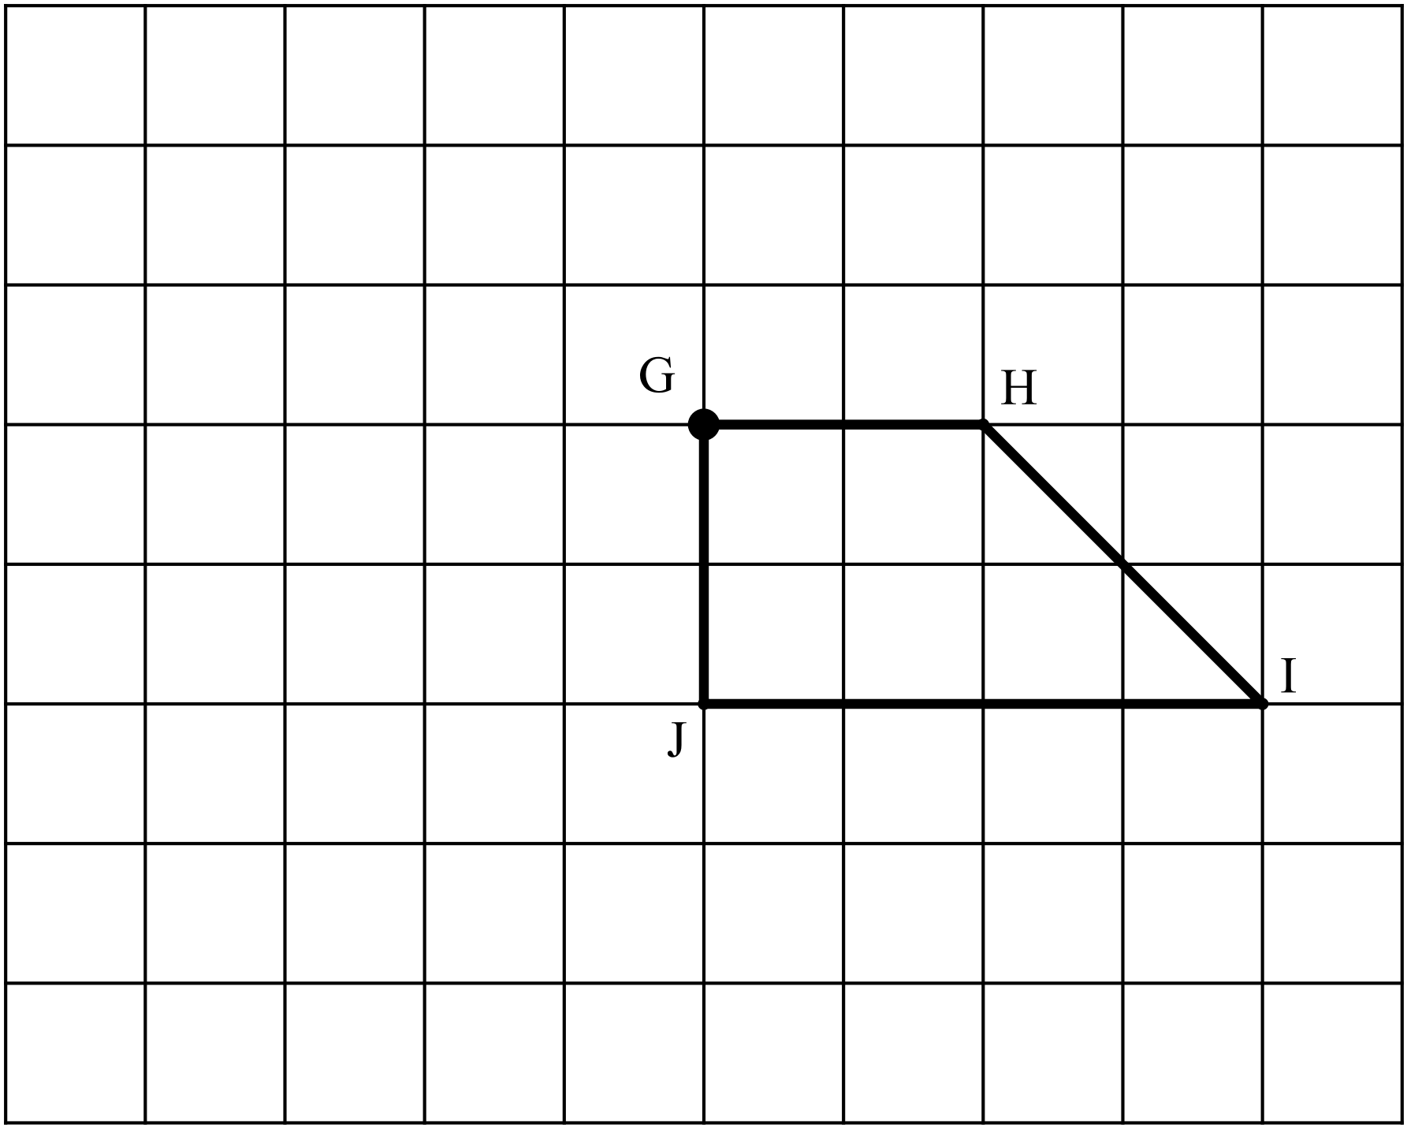 90° clockwise about point G b) 180° clockwise about point J
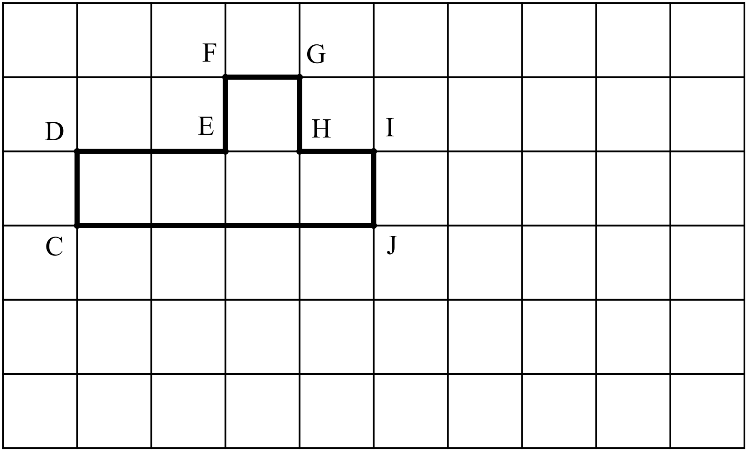

Question 4 (2 + 2 = 4 Marks)
For each transformation below:
- Determine what type of transformation is required to transform the object to the image shown.
- Give details of the transformation:
i.e.
If it is a translation state the direction and distance of the translation
If it is a reflection draw in the line of reflection
If it is a rotation draw in the centre point of rotation and
state the angle size and direction of rotation

- 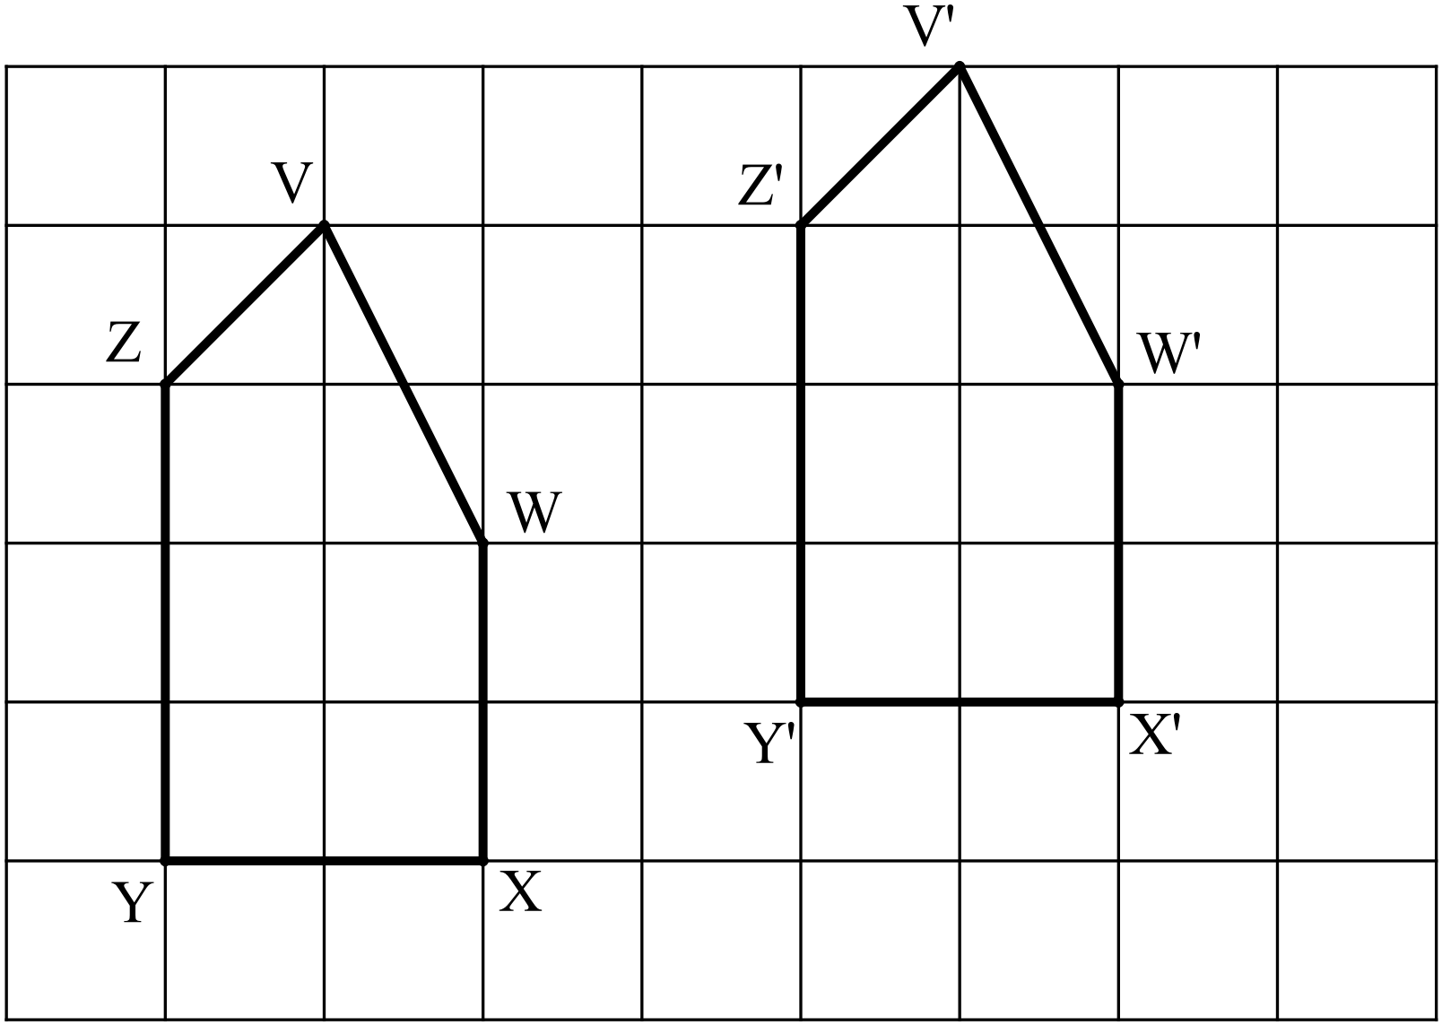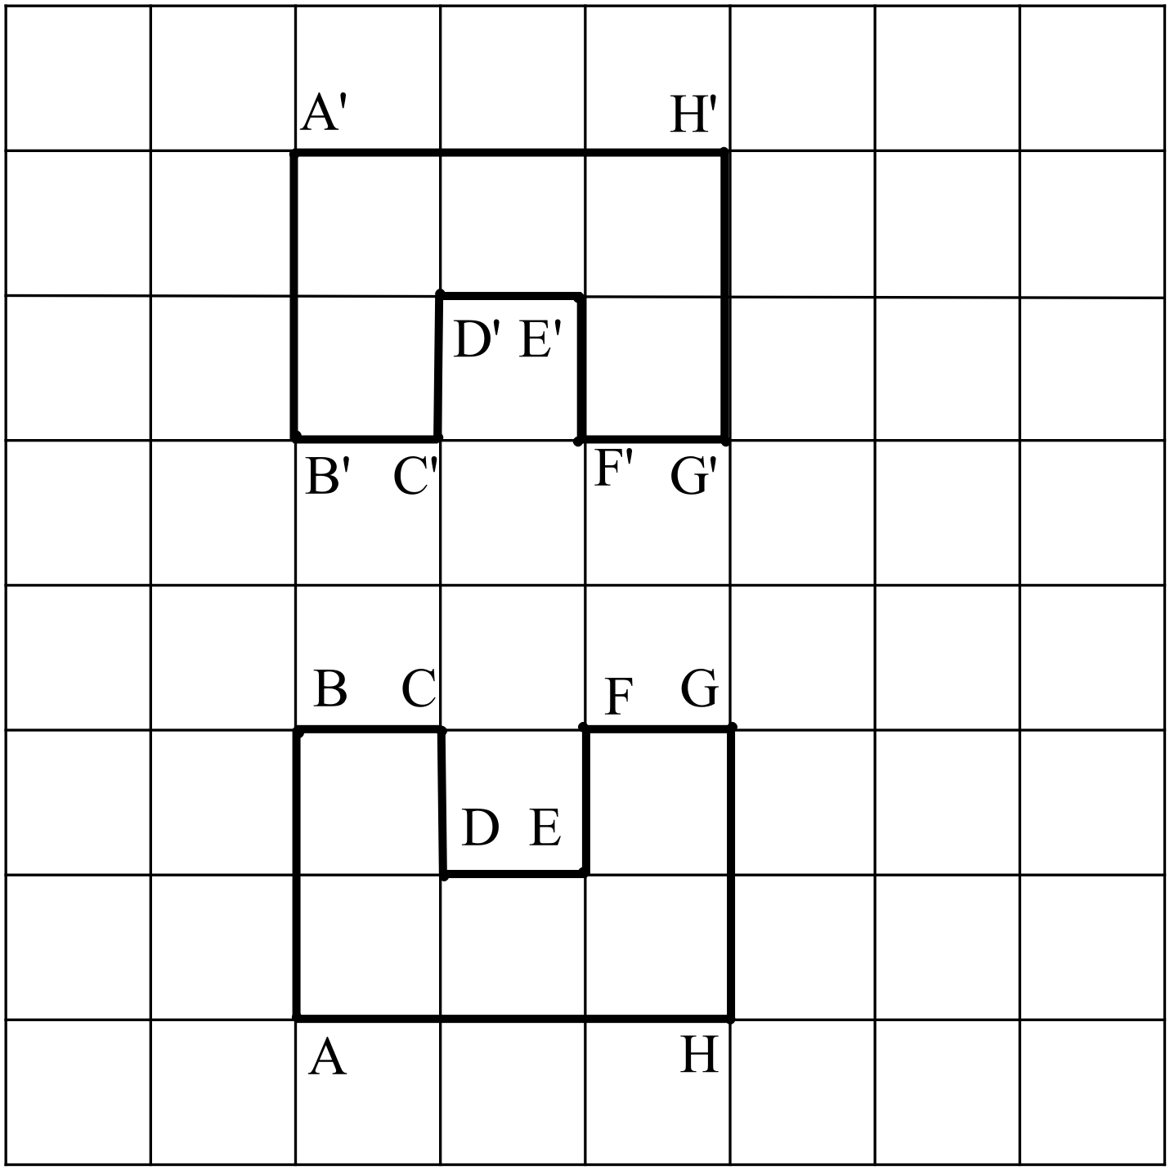 b)

i) (Type)__________________ i) ________________________
ii) (Details)_________________ ii) ________________________

Question 5 (1 + 3 = 4 marks)
The object below has been cut into three shapes
- Transform each object out of their current position*
- Draw it in its new position (its image)
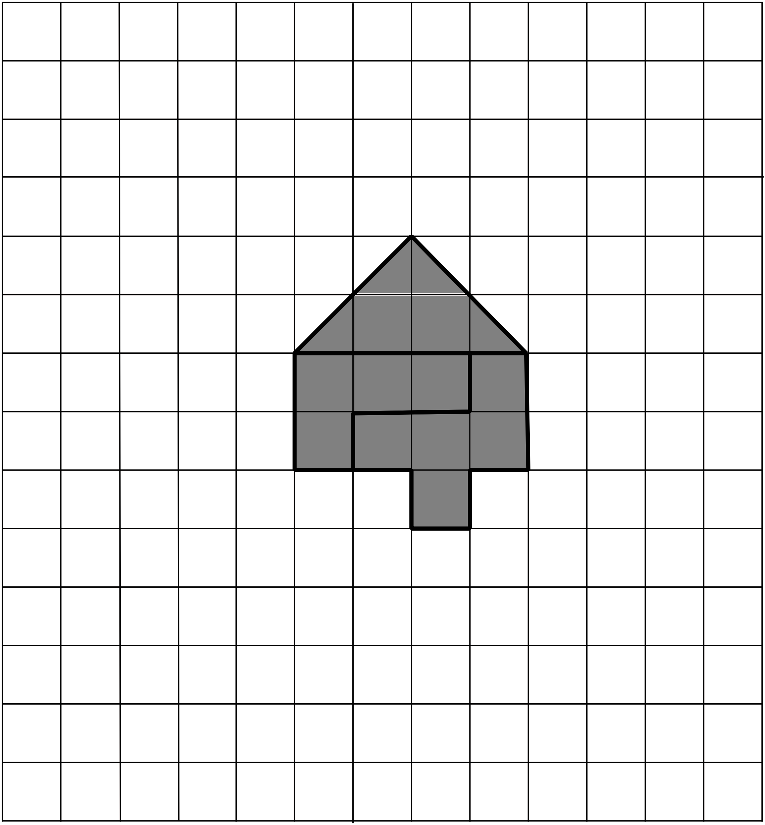

- Write the transformation for each of your images, to go back to their object.

* You may use one, two or three different types of transformations (ie translation, reflection, rotation).
More marks will be awarded if there is a greater variety of transformations used.

